**Activity Proposal Form Process User Guide**

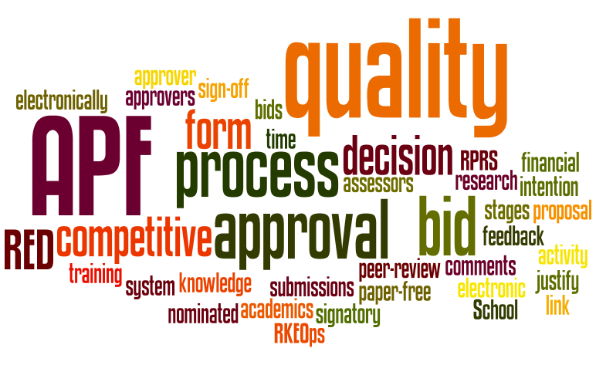

**Index**

Introduction Page 2

Intention to Bid Page 2

APF Process Page 2

Early Bid Stage Page 6

Quality Approval Stage Page 12

Final Approval Stage Page 13

Summary of APF approval signatory Page 15

APF Summary Page 16

Notes Page 16

Trouble-Shooting Page 18

Annex 1 – Intention to Bid Form Page 19

Annex 2 – Faculty information Page 21

Annex 3 – APF template Page 22

**APF Introduction**

The Activity Proposal Form (APF) process allows for the necessary approvals to be obtained electronically and introduces three possible stages to APF approval, depending on the type of application. This addresses the issues of quality for certain types of application and the timeliness of approval, whilst at the same time allowing for more flexibility in the approval process.

1. Early Bid Stage: for consultancy projects etc. where quality approval is not required; and to send the APF and ITB form to the Head of Department (HoD) and Head of Research (HoR) for their formal notification and approval.
2. Quality approval: since this was devolved to the Faculties (after the Review of Pre-award Processes in 2015), all Faculty DDRPPs, except for FST, have implemented mandatory QA. Where it is mandatory, QA is required for competitive research applications, regardless of value, e.g. Research Councils, EU and charities; and competitive knowledge exchange applications (e.g. tenders) where the value exceeds £50k (refer to Annex 2 for more information).
3. Final approval: To be sent to the relevant APF Approver in accordance with BU’s Financial Regulations (refer to Annex 2 for more information).

**Intention to Bid**

An Intention to Bid (ITB) form (Annex 1) must be completed for all types of application and is the document that will trigger any support to be provided by a [Funding Development Officer](http://blogs.bournemouth.ac.uk/research/contact/funding-development-team/) (FDO). The completed form will contain financial estimates, financial parameters, and basic information such as PI name, funder, deadline, scheme, and costing information etc. Based on the costing information provided in the ITB form, FDOs will provide the financial costings. This form will also be used at the Early Bid stage to enable approval to be granted (primarily by the relevant HoD and HoR). If the application requires Quality Approval, it is the PI’s responsibility to select the Approver from the relevant Faculty’s ITB annex – ‘Quality Approval’ and notify the Approver that the application will be sent to them in due course. A copy of the ITB form can be found at Annex 1.

**APF** **Process**

Before undertaking the electronic APF approval process, FDOs will ensure that all documents relating to the project have been uploaded onto RED through the project details screen, clicking on ‘Project Admin’ and ‘Documents’. The ITB form must be uploaded, along with the pFACT costing, CAF (if applicable), etc. All documents should be clearly named and uploaded against their relevant categories in order for their file type to be easily identifiable. For example, the ITB form should be uploaded against the ‘Proposal/tender’ category; pFact costing should be uploaded against ‘costing’, etc.

On the Project details screen, FDOs will click on ‘Project Admin’ and then ‘APF Summary’, which will display the following screen:

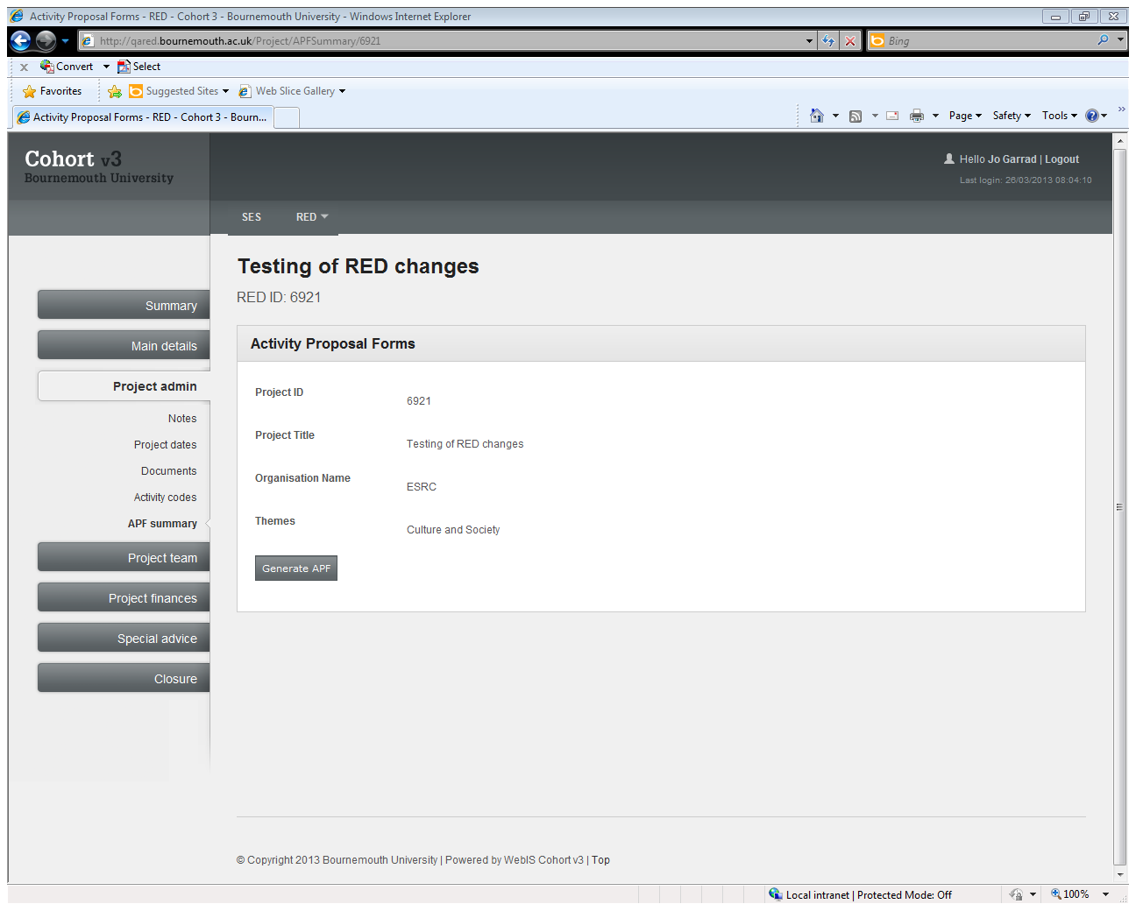

FDOs will then click on ‘Generate APF’ and the following screen will display all information about the proposed application:

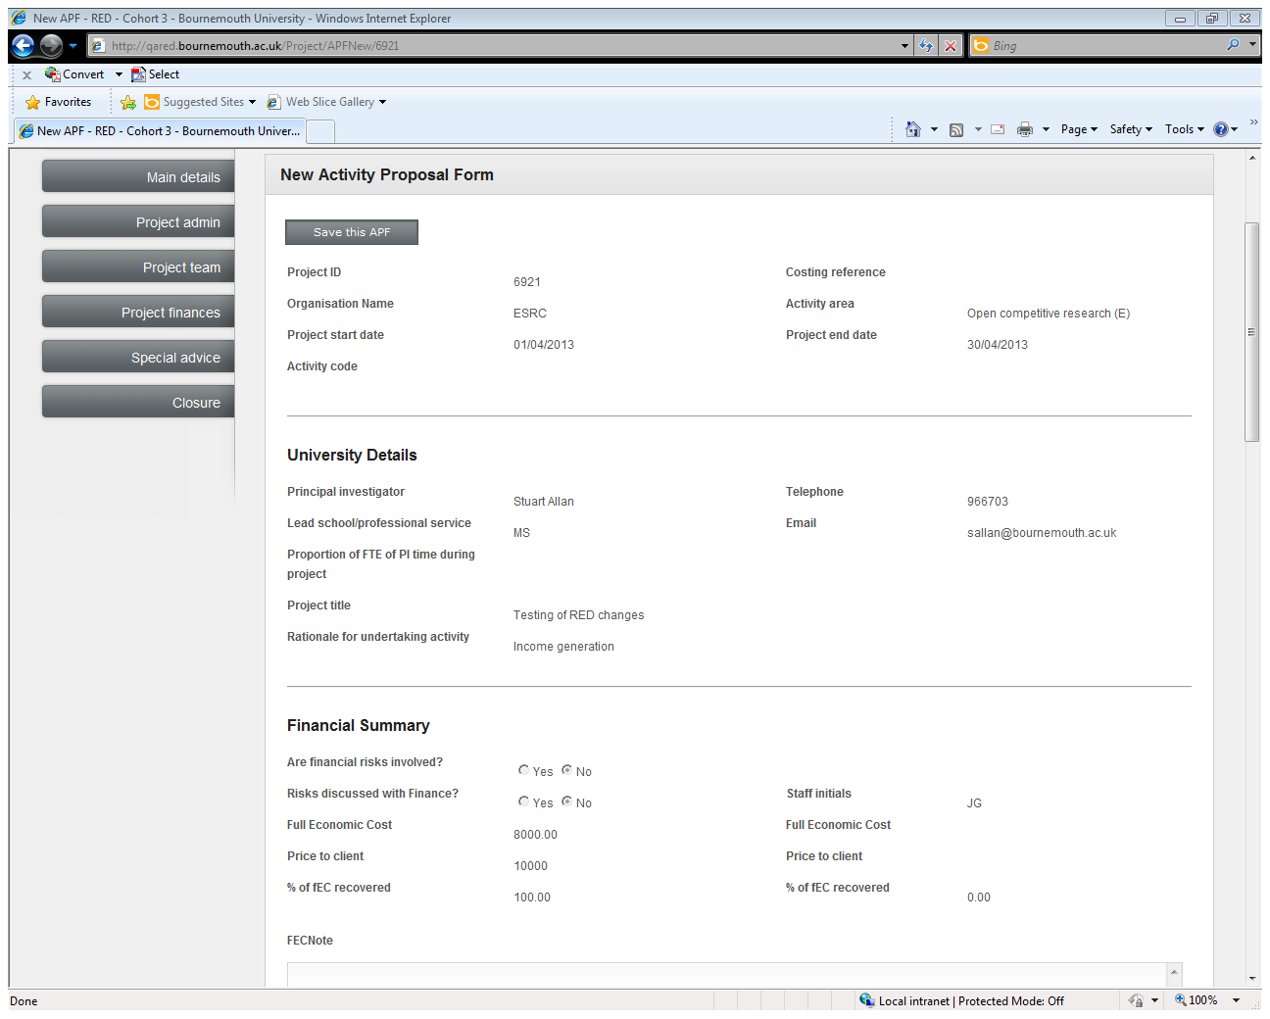

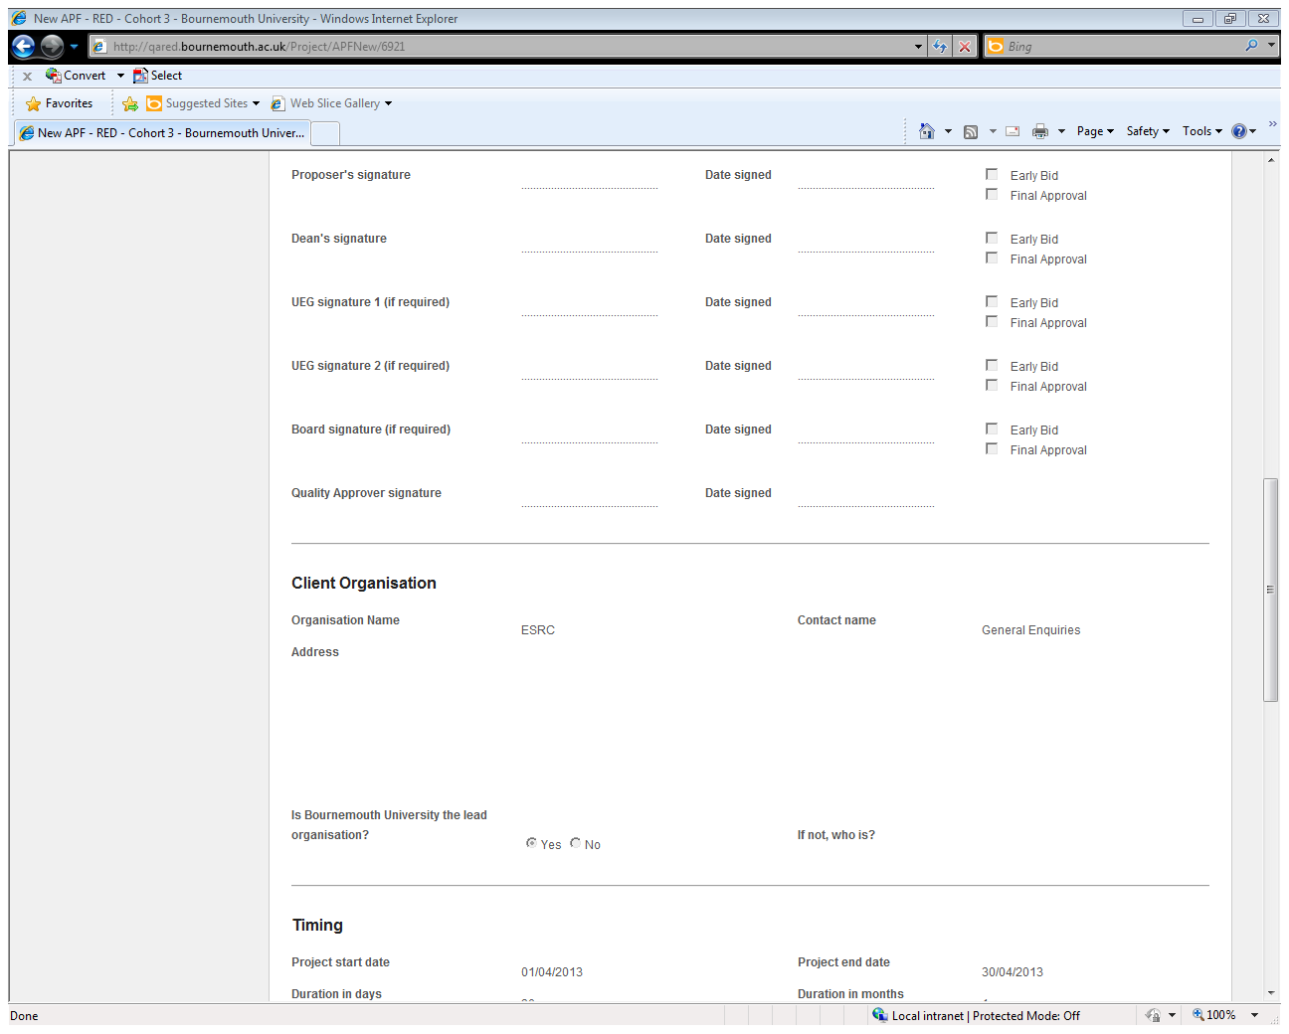

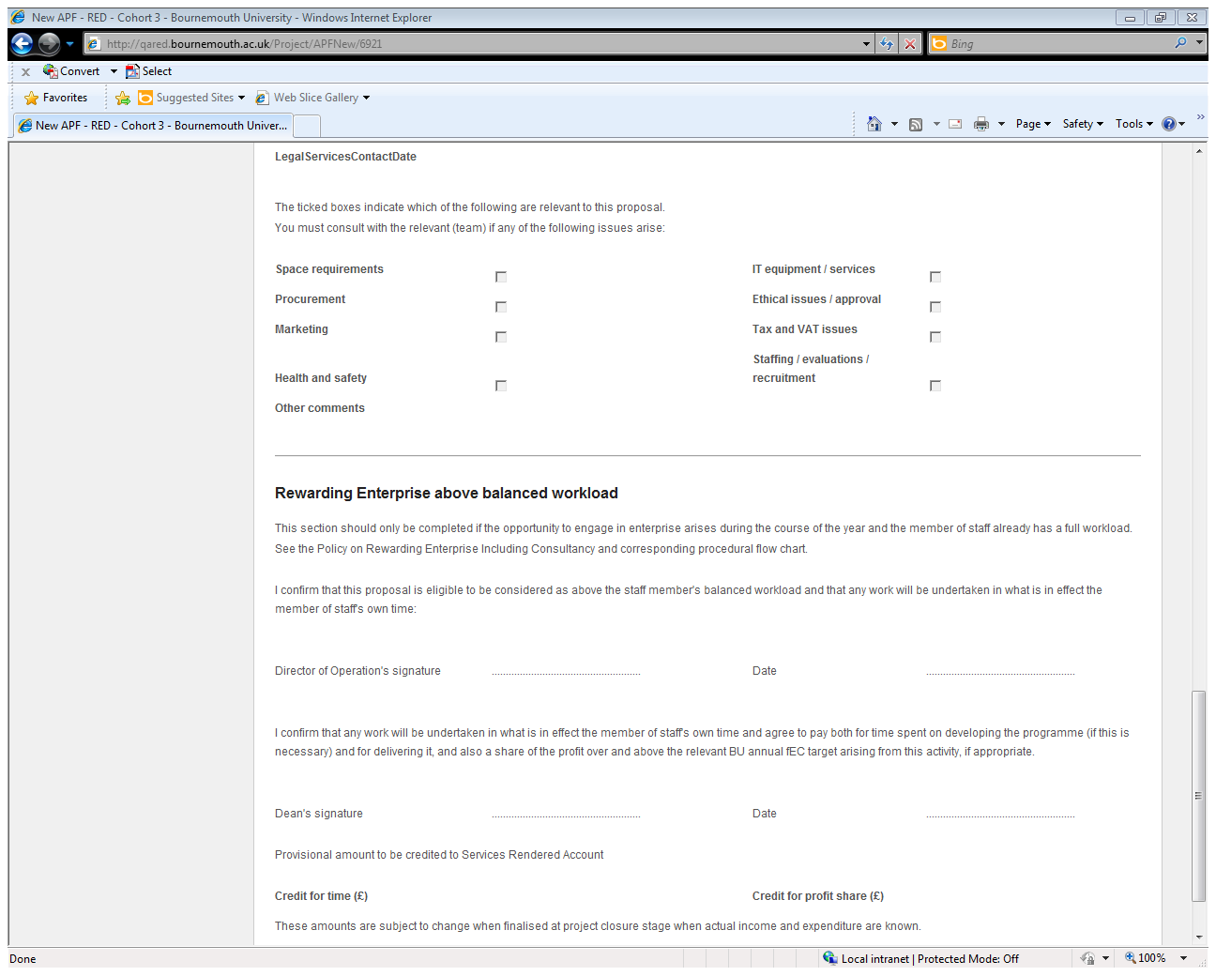

FDOs must click on ‘Save this APF’ before any actions can be carried out on the APF. Before saving the APF, ensure that all relevant project information is displayed, especially the Full Economic Cost (fEC) and the Price to client. For RCUK applications, check that the secondary fEC costing section is also filled out. Once saved, FDOs can go back into the APF by clicking on the APF ID shown (this will be a number) and proceed to the section on the APF called ‘Proposal Authorisation’:

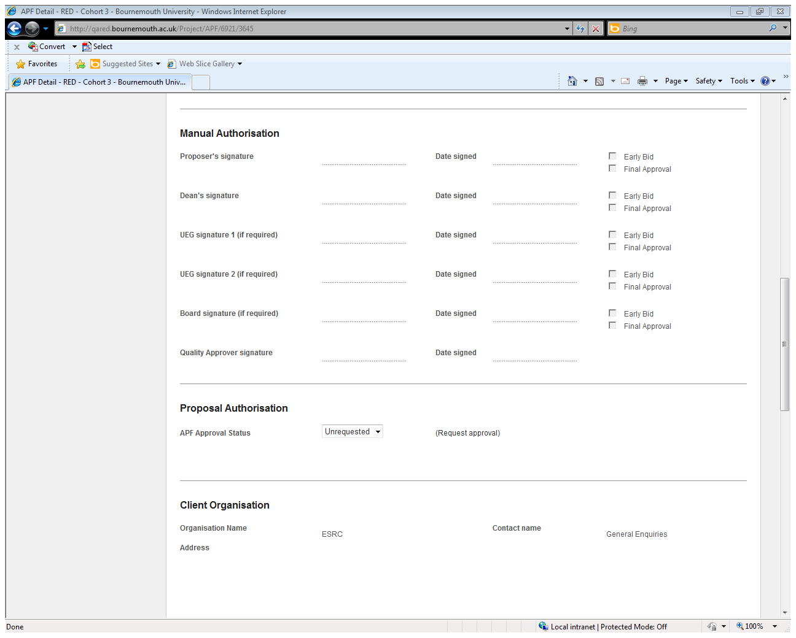

FDOs will click on the ‘Request Approval’ link and the following screen will be displayed:

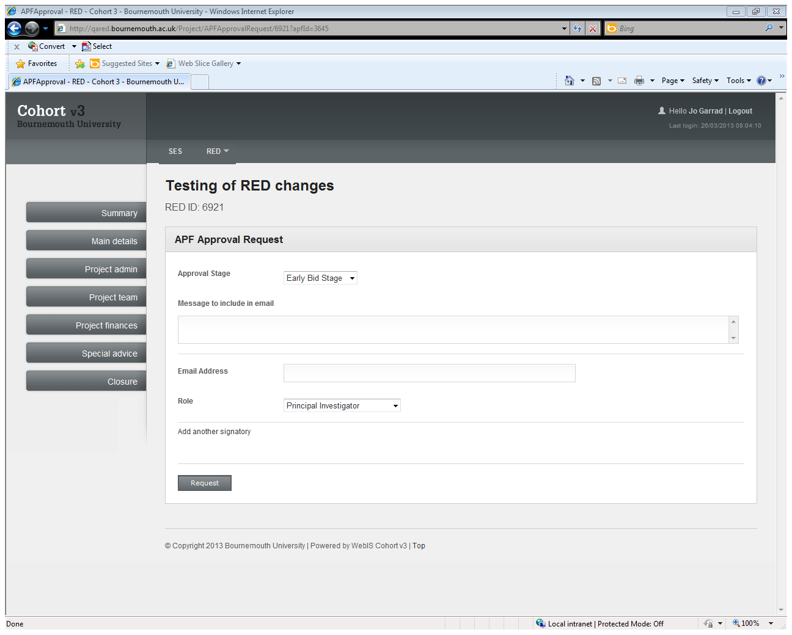

From this screen FDOs will be given the option to select which stage of approval is required along with the ‘Role’ of the person that they are sending the request to from the drop down lists:

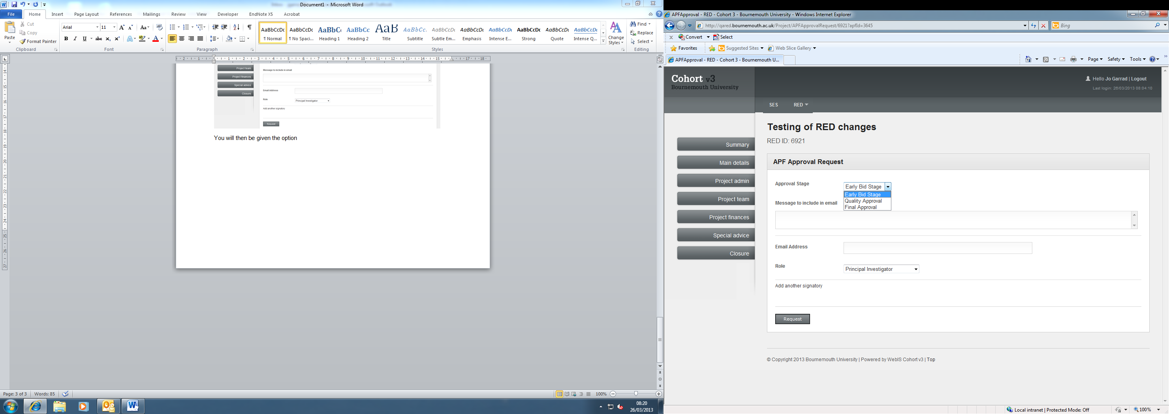 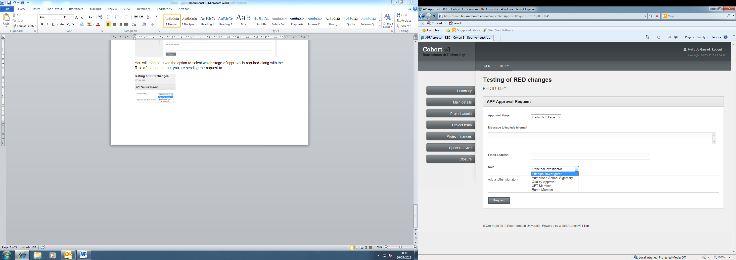

FDOs will need to enter the email address of the recipient, provide a brief of the project (refer to Annex 3 for the APF template) and select the appropriate approval stage of the application.

Please note that if this requires two UET or Board Members’ approval then requests will need to be generated for each signature required. This can be done by selecting ‘Add another signatory’ as shown below.



WARNING: Please note that you should select the correct ‘Role’ before inserting your project brief. Once you have populated your message, if you switch the ‘Role’, your message will disappear from the box.

**Early Bid Stage**

The Early Bid stage of the APF approval process is for the HoDs and HoRs to approve an ‘Intention to Bid’ from a PI. Please note that the Early Bid Stage mainly applies to consultancy projects adhering to BU terms and conditions as these only require financial approval. All other competitive research applications (including competitive knowledge exchange applications where the value exceeds £50K, e.g. competitive tenders) will first go through the Quality Approval stage (except for FST), before proceeding to the Final Stage approval. UET authorisation will only be required for applications over the value of £500k, and if CAF is required (as per current financial regulations) and these will be requested electronically, as described later on in the document. Board signatures are not required at the Early Bid stage.

Before an application is sent for final approval, PI approval has to be obtained.

*PI Approval stage*

To send an APF approval to the PI, select ‘PI Approval’ from the Approval stage drop down menu on RED. Once selected, you will see this screen:

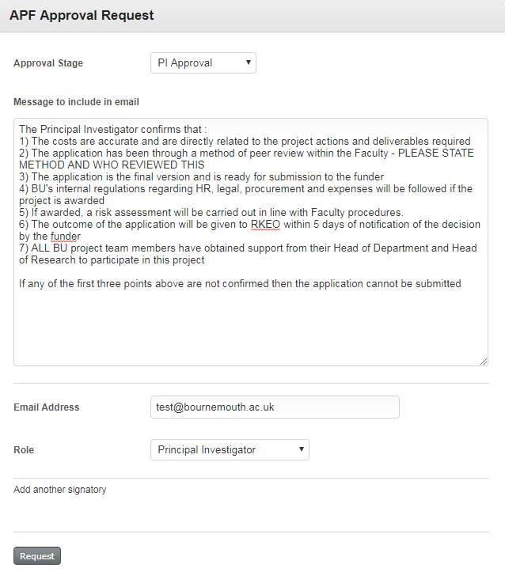

*Special note: If it is a consultancy project, it is suggested that FDOs should amend/ omit the points to ensure that they are applicable to the project, e.g. the final draft is not attached as it’s not yet available; or price quoted is based on hourly/daily rate, etc.*

Upon clicking ‘request’ an automated email will be sent to the PI for their approval, as shown below:

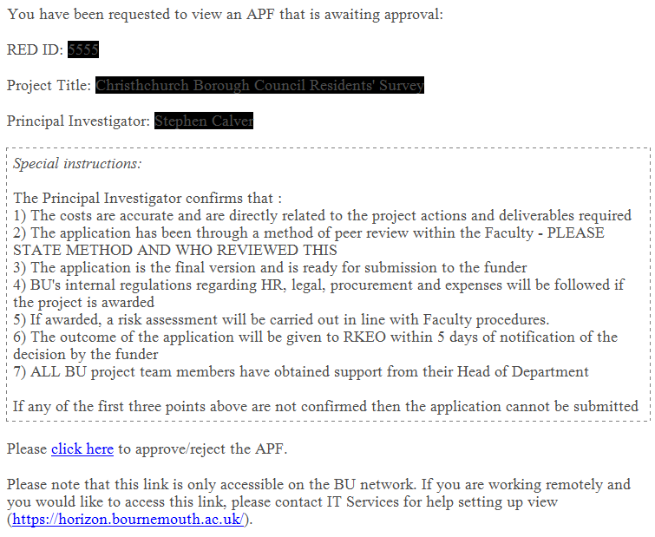

When the PI clicks on the ‘click here’ link, they will be presented with the following screen (please advise them that they do not need to log into RED to do this and that the link will only work on campus PCs).

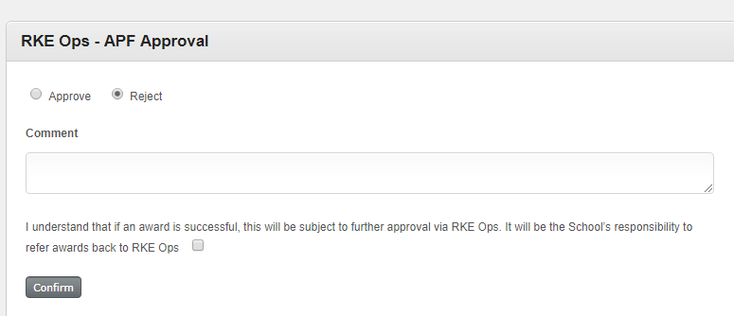

To complete this approval process, the PI is required to indicate the method and reviewer of their quality review process (except for FST) and confirm they have read and understood all other points.

If the PI is unable to access RED, an approval via email is also acceptable. However, FDOs are required to upload onto RED the PI’s email as proof of APF approval (FDOS will need to send the approval to themselves), as shown below:

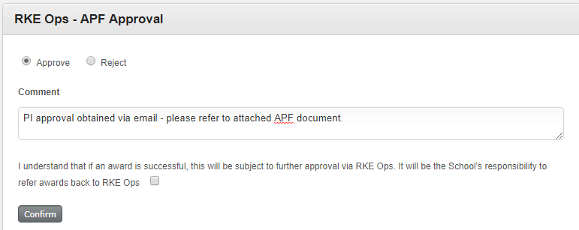

After PI approval is completed, the application can then proceed to the next approval stage.

To do this, FDOs will complete the following screen to indicate the stage of approval; include a project brief (refer to Annex 3 for template); the email address of the Approver; and their role. They will then click ‘request’:

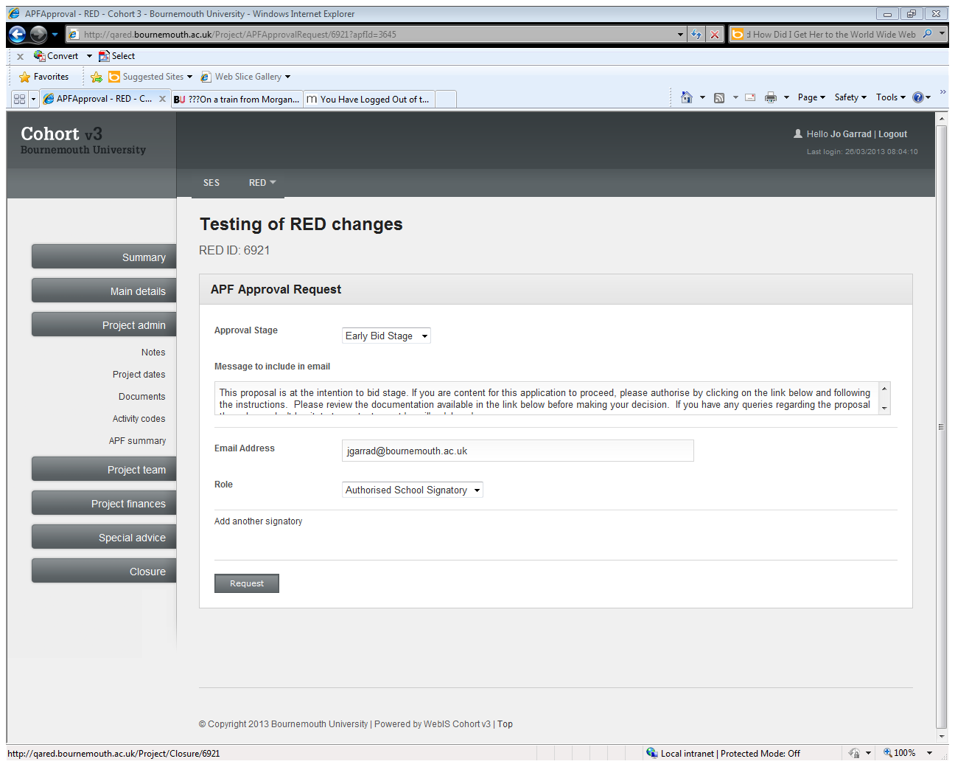

On clicking ‘request’, an email will then be generated and sent to the Approver. An example is shown below:

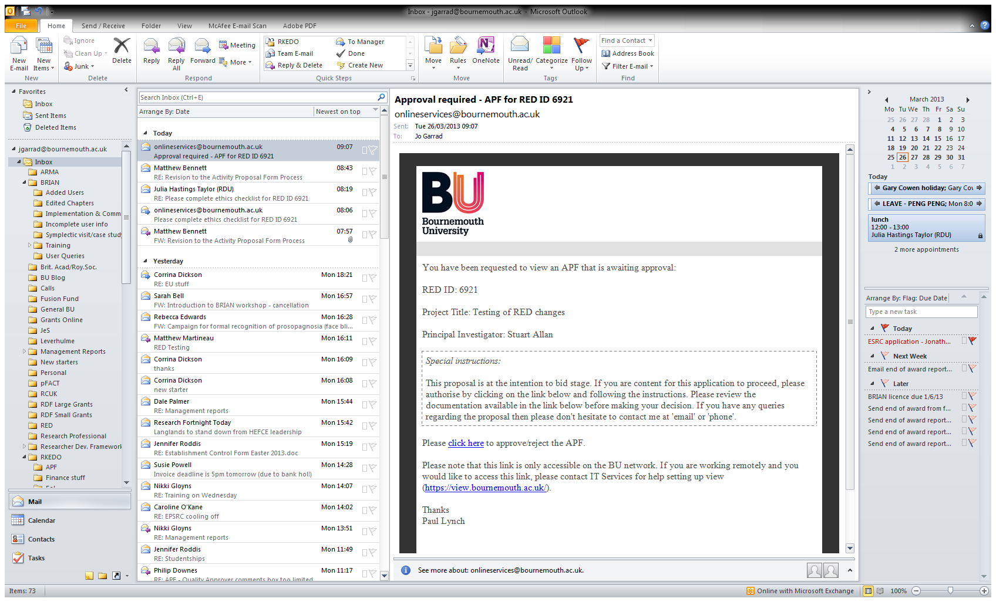

When an Approver (the email recipient) clicks on the ‘click here’ link, they will be presented with the following screen (please advise them that they do not need to log into RED to do this and that the link will only work on campus PCs), which will show what level of approval is required. Any documents uploaded will be shown in the ‘Project Documents’ field:

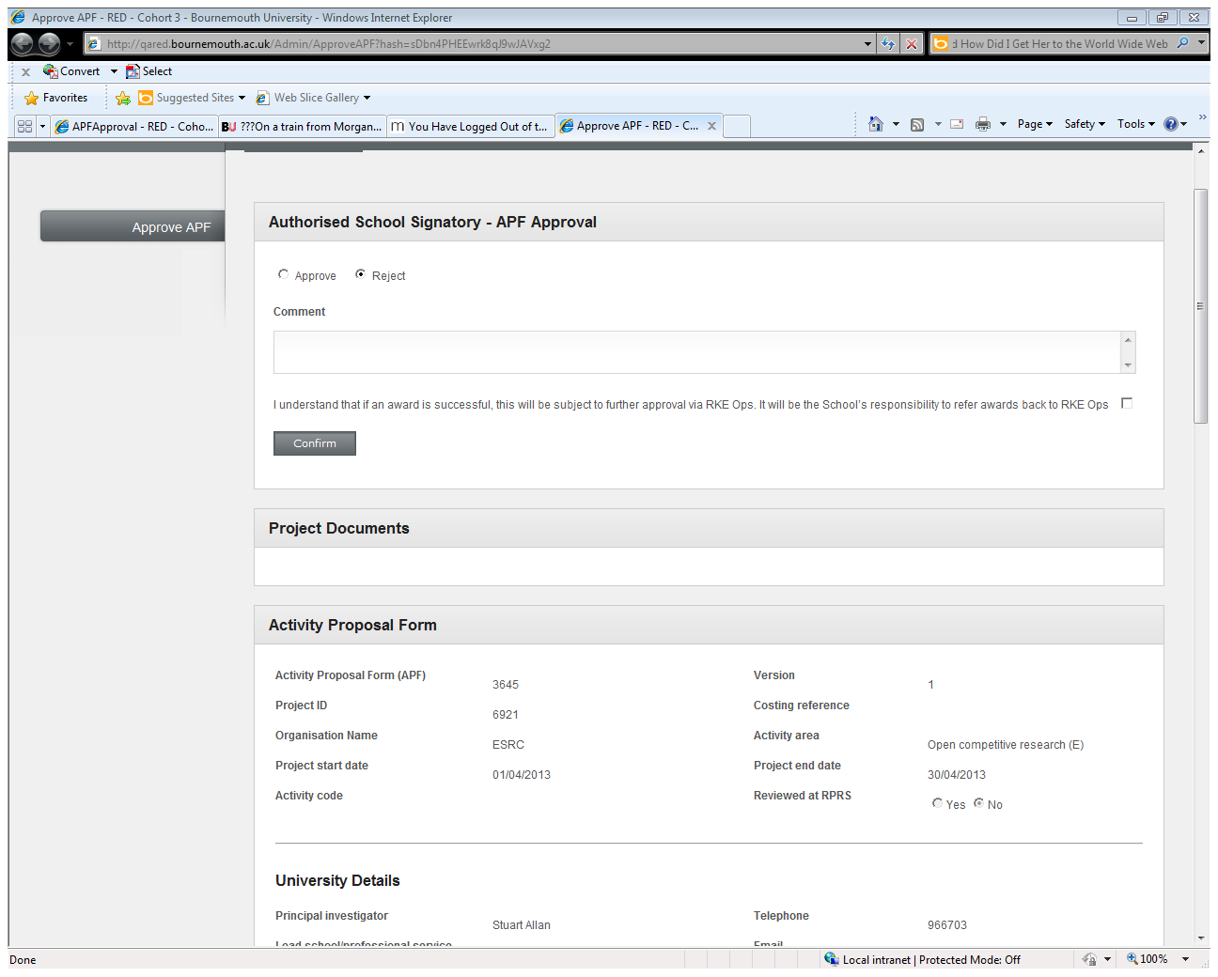

If an Approver chooses to reject the application, they will **need to add a comment to say why the application has been rejected before confirming their decision**. There is a standard message that all Approvers must tick to acknowledge that if the application is successful, it may be subject to further approval (whilst this is not necessary for rejected applications, we are unable to remove this message for rejections only and so please tick the box):

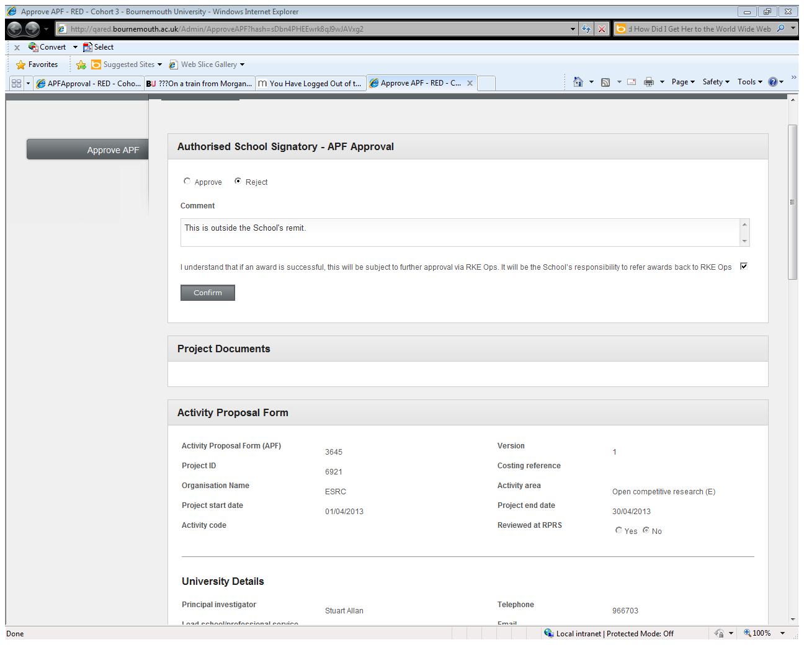

When an Approver clicks on ‘confirm’ the following screen will be presented to the Approver:

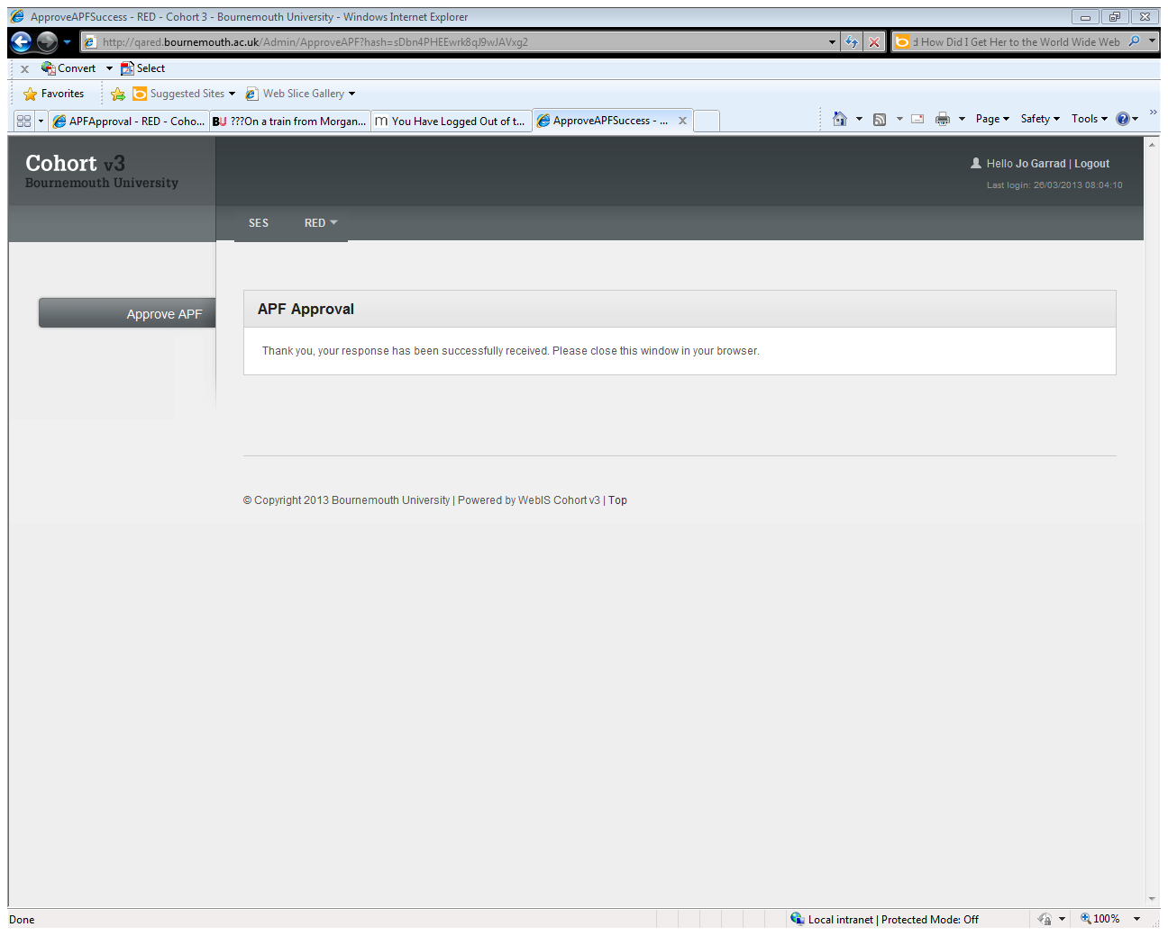

In addition, an email will be sent to the FDO contact to inform them that an action has taken place on RED for this application and the comments added by the Approver will be displayed:

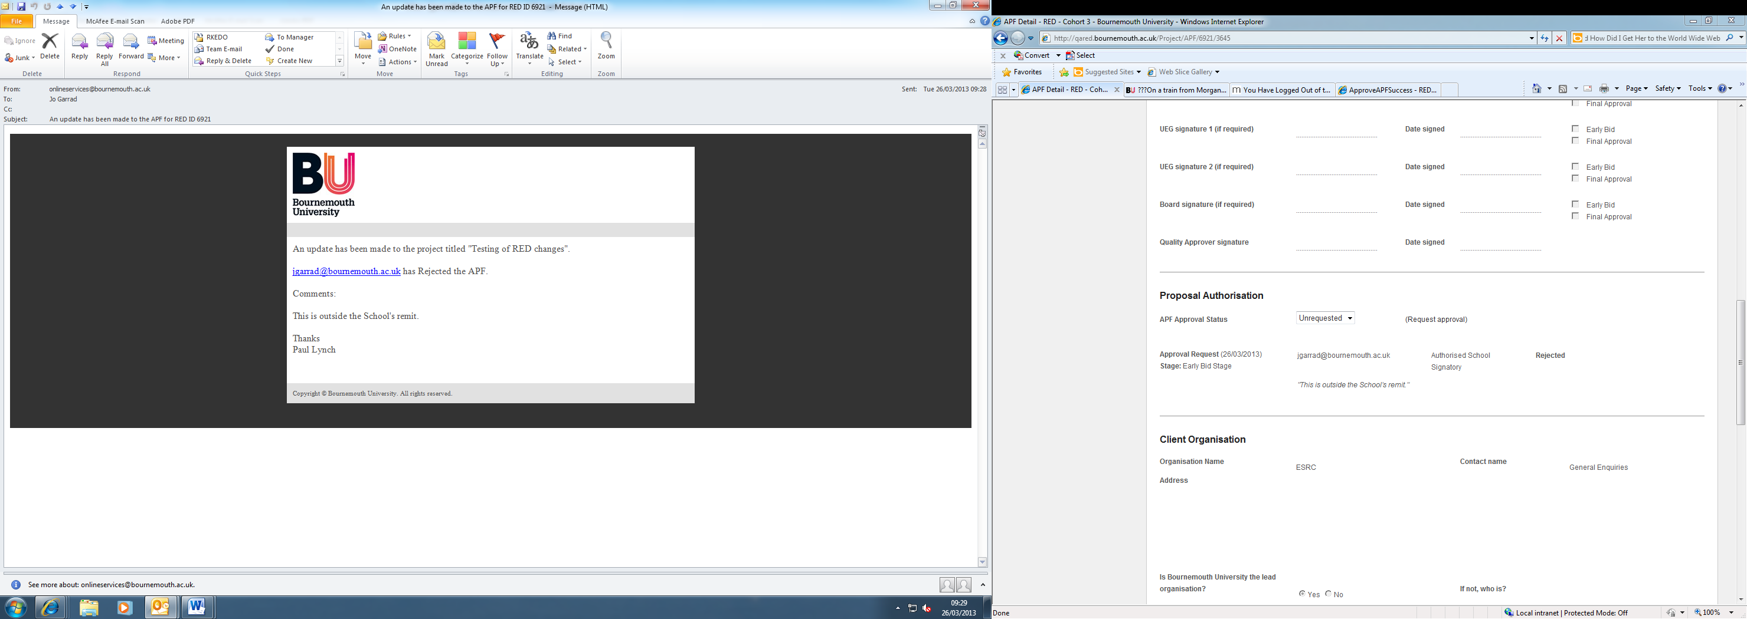

FDOs will need to log into RED to view any comments. The APF screen will display the approval history as follows:

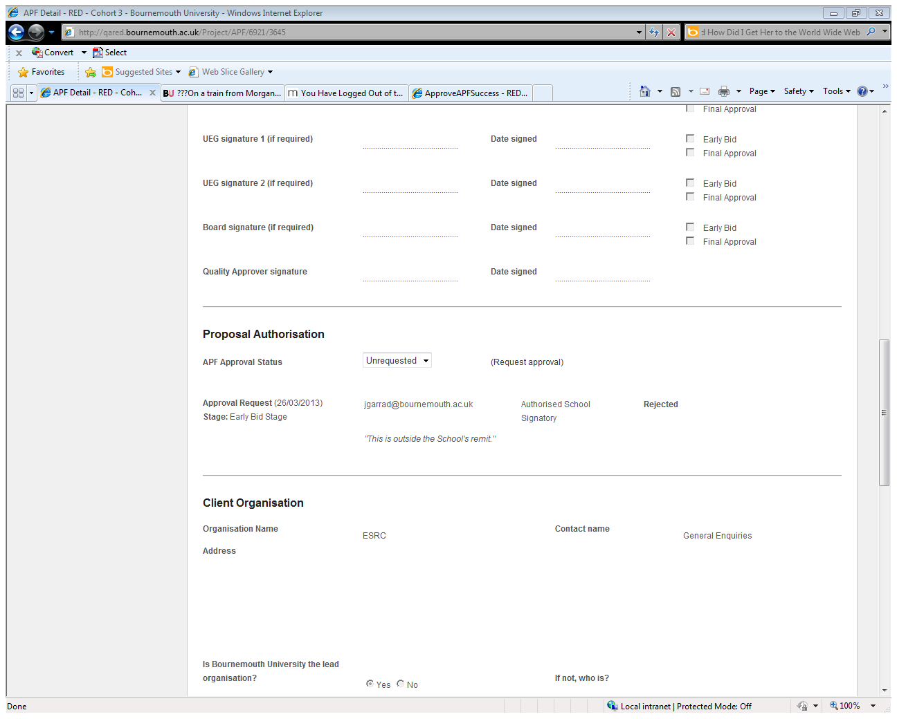

A rejected application at this stage should have its ‘APF Approval Status’ set to ‘rejected’ on RED by the FDO contact. The FDO will inform the PI that an application has been rejected.

If an Early Bid is approved, the Approver will complete the screen shown below. Please note that **comments are also required for approved applications**, along with acknowledgement that if the application is successful it may be subject to further approval:

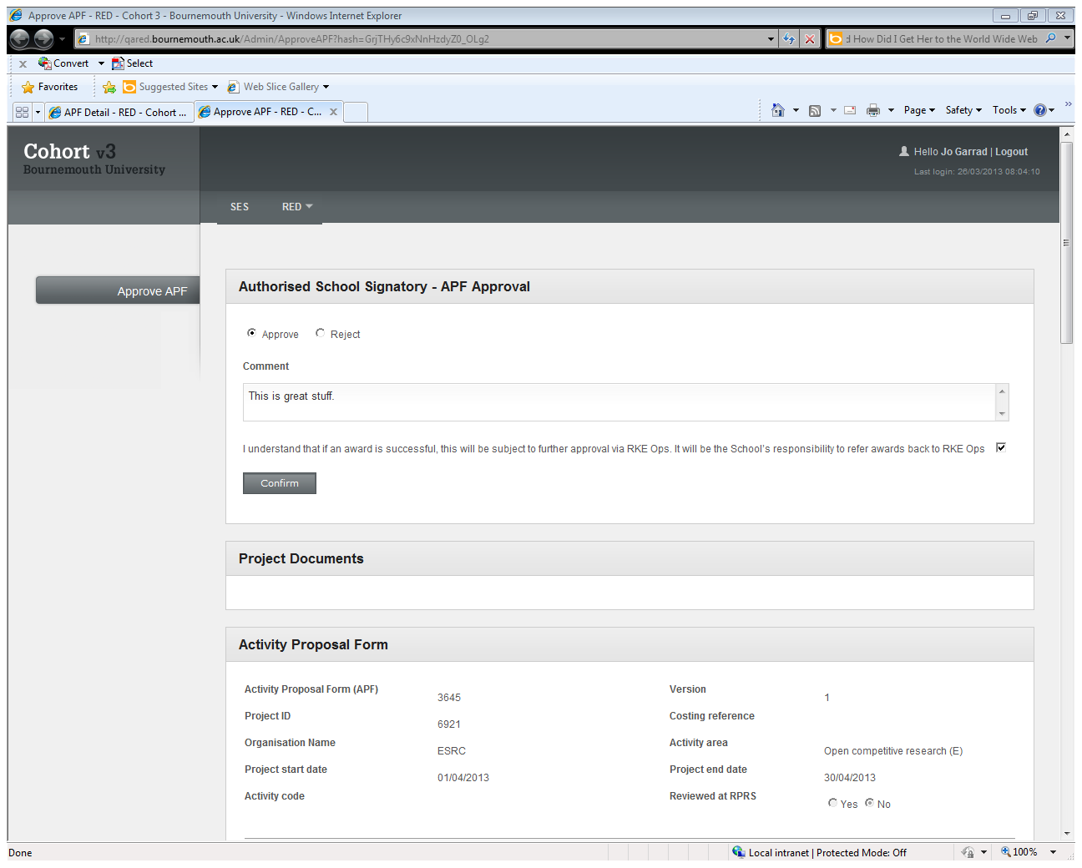

Clicking on ‘confirm’ will generate the same confirmation screen and email to the FDO contact as shown above for rejection.

**Quality Approval Stage**

The following applies on a mandatory basis to FHSS, FMC and FM (see Annex 2 for more information). It applies to FST where the FST Principal Investigator has elected to use the QA process.

The quality approval process is required to confirm that an application is of sufficient quality to be submitted for external funding (i.e. good enough to be submitted without reputational damage to the individual or BU). This stage is only required for competitive research applications or competitive knowledge exchange applications where the value is in excess of £50k (consultancy projects are excluded; please refer to Annex 2 for Faculty requirements). The application should be the final version at the Quality stage with all relevant documents, e.g. application forms, case for support, etc., uploaded onto the RED documents section by the FDO.

Since the ‘Review of Pre-award Processes in 2015’, the QA process is largely in the hands of the PI. The key role that the FDOs play in this process is ensuring that during the ‘PI approval’ process, point no.2 below is appropriately addressed by the PI.

The Principal Investigator confirms that:

*1) The costs are accurate and are directly related to the project actions and deliverables required*

*2) The application has been through a method of peer review within the Faculty - PLEASE STATE METHOD AND WHO REVIEWED THIS*

*3) The application is the final version and is ready for submission to the funder*

*4) BU's internal regulations regarding GR, legal, procurement and expenses will be followed if the project is awarded*

*5) If awarded, a risk assessment will be carried out in line with Faculty procedures.*

*6) The outcome of the application will be given to RKEO within 5 days of notification of the decision by the funder*

*7) ALL BU project team members have obtained support from their Head of Department and Head of Research to participate in this project*

If any of the first three points above are not confirmed then the application cannot be submitted.

**Final Approval Stage**

After the PI approval / Quality approval stages are complete, the application can then proceed to the Final approval stage.

Final approval is required by the relevant APF approver, depending on the fEC of the project in accordance with [BU’s financial regulations](https://intranetsp.bournemouth.ac.uk/policy/BU%20Financial%20Regulations.pdf). FDOs will generate an electronic Final Approval for the Authorised Faculty Signatory (usually Deans, Deputy Deans, or Directors of Operations (DOPs) depending on value) and/or two UET members to approve (refer to Annex 2 for more information). FDOs will submit a request by completing the following screen to indicate the stage of approval; include a brief of the project (refer to Annex 3 for template); the email address of the Approver; and their role. Please note that UET or Board Member (value >£500k, where required) authorisation may also be required at this stage so requests will need to be generated for each signature required. This can be done by selecting ‘Add another signatory’ as shown below:



With reference to the latest [BU Financial regulations](https://intranetsp.bournemouth.ac.uk/policy/BU%20Financial%20Regulations.pdf), applications with the fEC of over £500K can be signed off by the Dean or Director of Professional Service, along with any member of UET (who shall normally be the Pro-Vice Chancellor (Research and Innovation) plus one of the Vice-Chancellor, Deputy Vice-Chancellor or Director of Finance and Performance if a CAF is **not** required. If a CAF is required, Board approval will be required.

If Board authorisation is required at any stage (the value of an application is over £500k and if a CAF is required prior to application submission, as advised by Legal Services) then this will normally be requested electronically, unless on receiving the email notification the Board Member requests sign off via hard copy signature; or if the Board Member is unable to access the link provided (there are limitations to external access to the electronic APF – see Trouble-Shooting). If a hard copy signature is required, this will be arranged by FDOs. FDOs will provide Board Members with the appropriate documentation for the application and will be on hand to discuss any approval requests with Board Members.

FDOs will click ‘request’ and an email will then be generated and sent to the Approver. An example is shown below:

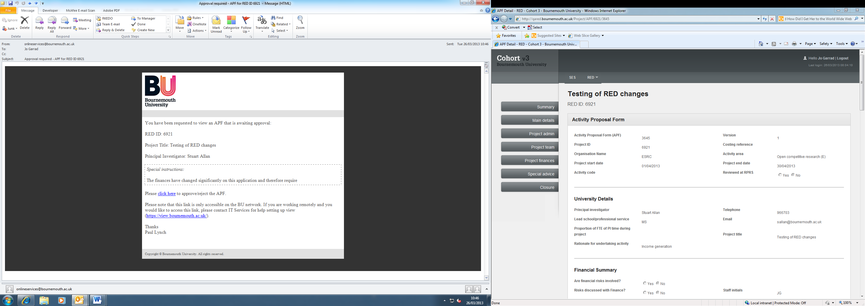

Clicking on the ‘click here’ link will take the Approver to the following screen where they will either approve or reject the application:

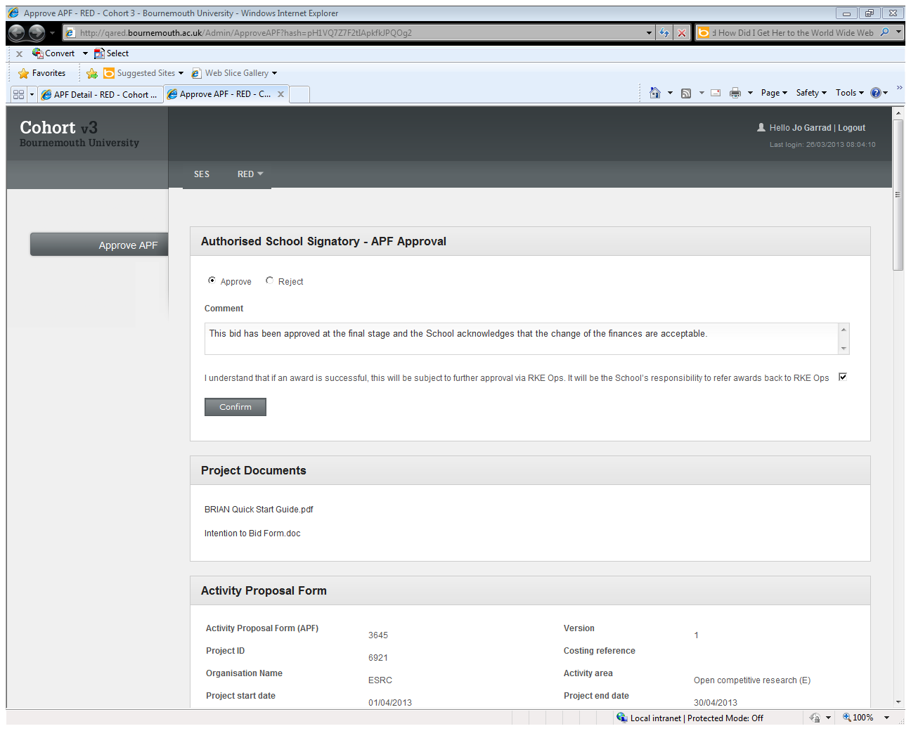

**The** **comments box may be completed to say why the decision was made if it is an approval and must be completed if it is a rejection**. Documentation displayed below the ‘confirm’ box should be read before a final decision is made. Please note that there is a standard message that all Approvers must tick to acknowledge that if the application is successful, it may be subject to further approval (whilst this is not necessary for rejected applications, we are unable to remove this message for rejections only and so please still tick the box). Failure to tick this box will result in a message to tick the acknowledgement before continuing. Clicking on confirm will show the following screen:



An email will be sent to the FDO contact to say that the APF has been updated and all comments will be displayed:

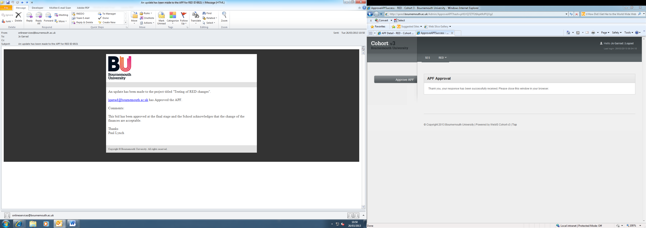

It is the FDO’s responsibility to ensure that the ‘APF Approval Status’ is updated as follows:

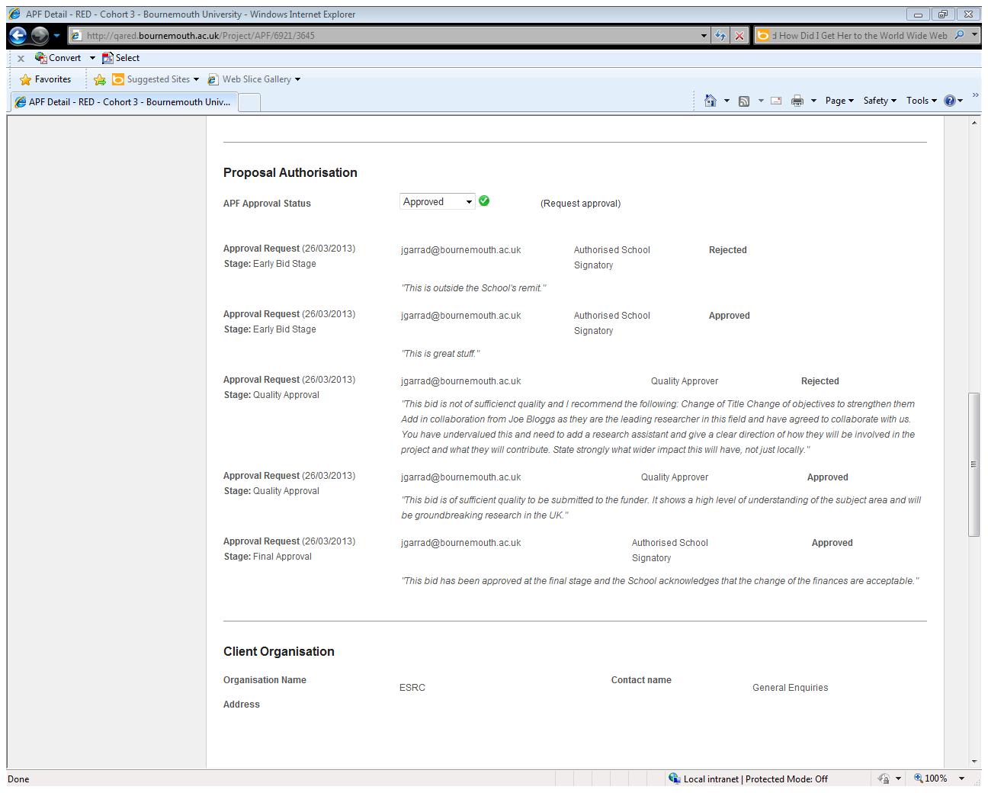

If Approval has been given at this stage, the application is now ready to be submitted. If an application has been rejected, the FDO will inform the PI of the decision and to discuss the rejection decision further with the relevant APF approver.

**Summary of APF approval signatory**

|  |  |
| --- | --- |
| **FEC** | **Signatory levels** |
| Up to £50K | * Dean; ***or*** * Director of Professional Service; ***or*** * Deputy Dean for Research and Professional Practice; ***or*** * Director of Operations |
| £50K - £500K | * Dean; ***or*** * Director of Professional Service |
| Over £500K  (no CAF is required) | * Dean ***or*** Director of Professional Service; ***and*** * Any member of UET (Pro-Vice Chancellor R & I); ***and*** * Vice-Chancellor; ***or*** Deputy Vice-Chancellor; ***or*** Director of Finance and Performance |
| Over £500K  (CAF is required) | * Dean ***or*** Director of Professional Service; ***and*** * Any member of UET (Pro-Vice Chancellor R & I; ***and*** * Vice-Chancellor; ***or*** Deputy Vice-Chancellor; ***or*** Director of Finance and Performance; ***and*** * Board approval (or follow advice from legal) |

**APF Summary**

Once an APF has received all appropriate approvals, FDOs should update the ‘APF Approval Status’ to ‘Approved’ as shown below:

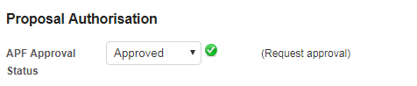

The summary screen will then reflect the status of the APF:

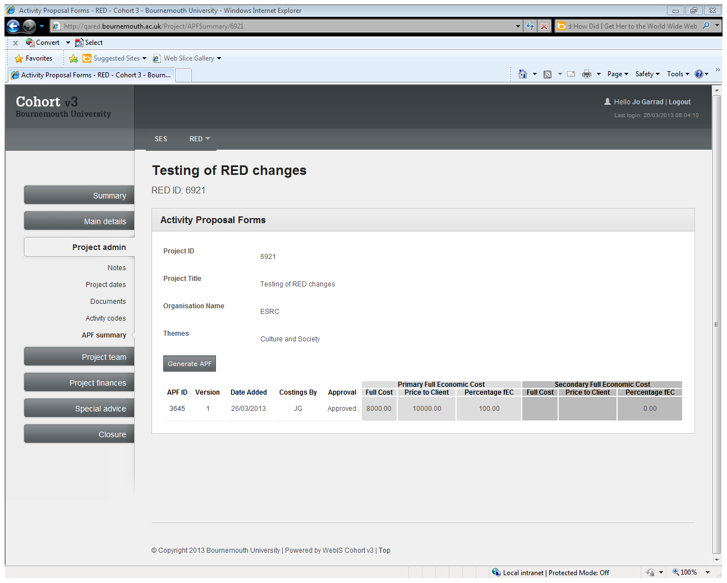

**To note:**

1. Applications requiring Quality Approval will primarily be those that we are lead on. However, this can also apply when we are non-lead in certain circumstances. There may be comments that Approvers can make on strengthening the BU aspect; if we are ‘a jewel in a muddy field’ then Approvers can suggest that we should not be collaborating with someone who may damage our reputation, or offer suggestions to be taken forward with the lead.
2. **Comments may be added by all types of Approver if they approve the application**. Comments must be added by the Approver if they reject the application. A clear audit trail needs to be shown and decisions need to be justified. All comments made will be displayed in the relevant emails sent to the FDO contact to say that an update has been made to the APF.
3. In the QA process where it is used (this applies to the points below regarding QA), Quality Approvers have to take a generalist view of an application. It is not possible to send applications that are only in their field of expertise.
4. In addition to 3), value for money is not to be considered. Also, an application has to be of sufficient quality regardless of the type of call. BU will not put an insufficient application into a call just because the call is a one-off. PI’s should ensure that they have allowed sufficient time to incorporate feedback if the call is one-off. There will be occasions (for reactive bids) where a short turnaround is given, i.e. 4-6 weeks. Quality Approval is still required and should not inhibit short scale bidding.
5. For applications that do not require a CAF prior to submission (e.g. Research Councils) the CAF will be completed at the contract authorisation stage (when contractual terms are known). Where applications do require a CAF prior to submission (e.g. responding to a tender that has non-negotiable terms that the response accepts) then the CAF document will be uploaded onto RED as part of the Final Approval stage.
6. KTPs (Knowledge Transfer Partnerships) have regional consultants who approve applications to be submitted. Quality Approvers will be sent the regional consultants confirmation that the application can proceed and approve it on this basis.
7. Faculty DDRPPs have provided RKEO with a list of Quality Approvers, which are incorporated into each Faculty’s ITB ‘Annex – QA’. FDOs will provide PI’s with the ‘Annex – QA’ for their Faculty when completing the ITB form.
8. Where RKEO know of several applications being made to the same scheme/call, they will inform the Deans and DDRPPs to ensure that sufficient resources are available to review the applications. The QA process is now largely the PI’s responsibility and should involve the PI working closely with their peer reviewer through several iterations of the proposal to bring it up to a high and competitive standard. RKEO monitors how this is done through sending the APF for the PI’s Approval close to the submission deadline.
9. All appeals to a decision can be made directly to the PVC (Research & Innovation) who will adjudicate differences of opinion on the basis of their own review of the application. The APF process will be reviewed in the Spring 2018. Audits will also be carried out on the Quality Approval process in Spring 2018.

**Trouble-shooting**

**Problems opening documents** – some versions of IE and Firefox may cause documents to hang when opening. If this message appears but stays the same for a couple of minutes press cancel and the document will open:

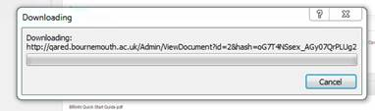

If asked to log-in close that window too (it may need to be done three times) and the document should still open:

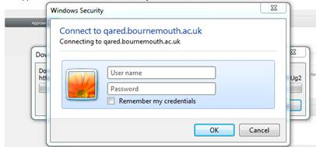

**Accessing RED remotely** – The process is linked up to RED and whilst you won’t have to log-in to RED, when you are sent a link to carry out an approval, it will take you to a RED screen. This link is only accessible on the BU network. Therefore, if you are working remotely and you would like to access this link, you will be able to do this via Horizon View. If you have not set up View and you are likely to need to carry out approvals remotely, you will need to request to be ‘added to a Group to access View’ through either a Snow request (<https://bournemouth.service-now.com>) or by telephone, on ext. 65515. Once this is established, there are installation guides on Snow. If you log-in to Snow and click on ‘Knowledge’ on the left-hand side, and then type ‘View install’ in the search box, a number of different links and documents will show enabling you to install View (there are guides for PCs, iPads, etc.). If you have any problems with installing this then do contact IT Services via the contacts above for help with setting up Horizon View.

**Annex 1: Intention to Bid Form**

*For the most up to date version of the Intention to bid form, please always check:*

*RKEO>Private>Funding Development Team>Best practice and guidance documents>Intention to Bid forms*

|  |  |  |  |  |  |
| --- | --- | --- | --- | --- | --- |
| **RKEO Contacts** | Kerri Jones (SciTech) [kerrij@bournemouth.ac.uk](mailto:kerrij@bournemouth.ac.uk) (Ext. 61254)  Alice Brown (SciTech) [browna@bournemouth.ac.uk](mailto:browna@bournemouth.ac.uk) (Ext. 68247)  Pengpeng Hatch (FHSS) [pphatch@bournemouth.ac.uk](mailto:pphatch@bournemouth.ac.uk) (Ext. 61354)  Sara Mundy (FM) [smundy@bournemouth.ac.uk](mailto:smundy@bournemouth.ac.uk) (Ext. 68253)  Eva Papadopoulou (FMC) [epapadopoulou@bournemouth.ac.uk](mailto:epapadopoulou@bournemouth.ac.uk) (Ext. 68252) | | | | |
| **Principal Investigator & Co-Investigator/s** |  | | **Estimated % effort of PI and Co-Is preparing the proposal** *Eg. Jane Bloggs 75%, Joe Doe 25%* | | |
| **Deadline** | Click here to enter a date. | | | | |
| **Funding Organisation/Stream** | ***(1) Funder: (2) Call name: (3) Web-link****:* | | | **Project type** | Choose an item. |
| Others |  |
| **Project Title** |  | | | | |
| **Project dates** | ***(1) Start date:*** Click here to enter a date. ***(2) End date:*** Click here to enter a date. ***(3) Duration:*** | | | | |
| **BU as Lead? Collaboratos?** | *Is BU the Lead?*  **YES**  **NO** | *List partners/collaborators, if any:*  *\*If non-HEI collaborators are involved, please also complete the Non-HEI collaborator contribution annexure* | | | |
| **Project summary** | *Brief couple of sentences about key objectives of the project* | | | | |
| **HoR & HoD Support** | **PLEASE COMPLETE THIS SECTION**  *Please name your Head of Research:*  *Please name your Head of Department:*  *Please confirm that your (and your Co-I’s) Heads of Research & Department support this bid.* **YES**  **NO**  *Please confirm that all other external partners and BU co-Is have been notified of their involvement and have consented to sharing their salary info/personal details. Please refer to the* [*GDPR Guide*](https://ico.org.uk/for-organisations/guide-to-the-general-data-protection-regulation-gdpr/) *for more info.* **YES**  **NO**  ***\*Head of Research MUST be copied into the email when this form is returned to RKEO.*** | | | | |
| **Funder Guidance/** | *Please confirm that you have read the Funder’s Guidance.* **YES**  **NO** | | | | |
| **Conflicts of interest** | *Have you read* [*BU’s Conflicts of Interest Policy and Procedures*](http://intranetsp.bournemouth.ac.uk/policy/Conflicts_of_Interest_Policy_and_Procedures%20v4.doc)*?***YES**  **NO**  *Are there any potential conflicts of interest? If Yes, please provide details below:***YES**  **NO**  *Details: …………………………………………………………………………………………………* | | | | |
| **Benefits to BU/ the Faculty/ individual** | *Please state the benefits and rationale behind the project. This information will be used for the approval process. E.g.*   * *Lead to REF outputs,* * *seed funding to lead to future research,* * *International collaboration,* * *income generation, etc.* | | | | |

**Costing Information Request  
(IMPORTANT – You must complete this section)**

|  |  |
| --- | --- |
| **BU Staff Time**  **(Who will work on the project, which Faculty & for what allocation of time?)**  ***PI time?***  ***Co-I time?***  ***(any others?)*** | *Eg.* ***Jane Bloggs (FHSS)*** *for 2 hours per week over project period;*  ***Joe Doe (FST)*** *for 0.5 hours per week over project period.* |
| **Student or Research Assistant Costs (if applicable)** | ***Note full or part-time over project period and Faculty where based.***  ***For RA, note pre-doc (Grad or Masters level) or post-doc (PhD level).*** |
| **Projected Non Staff Costs**  **Travel**  **Consumables**  **Equipment**  **Subcontract**  **Publications**  **Other** | ***Eg. Return travel to London for Jane Bloggs, 1 conference, 2 nights stay in London = (estimated costs);***  ***Return travel to Berlin for Joe Doe, 1 international conference, 3 nights stay in Berlin = (estimated costs); etc***  ***If this is a cross-Faculty bid, if more is known about the estimated funding split between Faculties, please indicate the estimated split here.*** |
| **Funding available (if known)** |  |

**Annex 2 – Faculty information**

|  |  |  |  |
| --- | --- | --- | --- |
| **Faculty** | **Quality approval mandatory** | **Authorised signatories** | **Special note** |
| FST | Optional | Dean = Keith Phalp  DDRPP = Tiantian Zhang  DoP = Kelly Deacon-Smith | If anything under £50K, recommended to send to DoP instead of DDRPP |
| FHSS | Yes (but only when BU is lead) | Acting Dean = Vanora Hundley  DDRPP = Vanora Hundley  DoP = Deirdre Sparrowhawk |  |
| FM | Yes | Dean = Stephen Tee  DDRPP = Mike Silk  DoP = Rob Hydon |  |
| FMC | Yes | Dean = Keith Phalp  DDRPP = Iain MacRury  DoP = Mark Brocklehurst |  |

**Annex 3 – APF template**

Re: **RED**  – *[title]*

**Applicant:**

**Name of Funder:**

**Project Dates:**

**Funder’s deadline:**

**Internal Deadline:**

Please see the following information concerning the application, which is provided to assist you in your decision:

**Current staff (Directly Allocated)**

*The following members of staff will require this time to be allocated to this research project:*

**New staff (Directly Incurred)**

*The following new staff will need to be hired and workspace provided for them:*

**Cost Implications**

**Full economic cost:** £

**Income:** £ **(according to funding rules)**

**Net Cost/Gain to BU: £ (Real cost to be paid)**

***{Calculated by subtracting Directly Incurred costs from Grant Income}***

**Recovery rate:** % (Income divided by FEC)

**Benefits to BU *{wording below to be customised}:***

* Lead to REF outputs that can be submitted and higher QR funding
* Prestige and reputational benefit
* International collaboration
* Business engagement, etc.
* Lead to improvements in pedagogy

**Documents attached for further appraisal:**

1. Intention to Bid form
2. pFACT costing
3. Application
4. CAF exemption form *or* CAF *or* Legal Services’ advice that a CAF is not required at this stage
5. Funder guidance.

Please review the documentation attached and make your APF decision by clicking on the link below. If you have any queries regarding the proposal, please do not hesitate to contact me. Many thanks.